1. **Setting the MOTD (Message of The Day)**

|  |
| --- |
| **Verify:** |

1. **Setting password on switch within cisco packet tracer**

|  |
| --- |
| **Verify:** |

1. **Removing the password from the switch:**

|  |
| --- |
| **Verify:** exit and then login again to same switch |

1. **Configuring username and password on switch**

|  |
| --- |
| **Verify:** |

1. **Configuring secret (way to lock the enable mode on switch)**

|  |
| --- |
| Type password “pass@word1” to login.    Type secret “secrettext” to enable admin access.  **Viewing the secret value (encrypted)** |

1. **Saving the configuration to NVRAM:**

|  |
| --- |
|  |

1. **Showing the MAC table**

|  |  |  |  |  |
| --- | --- | --- | --- | --- |
| |  |  | | --- | --- | | **On switch – before pinging 2 machines** | **On switch – After pinging** | |  |  | |

|  |
| --- |
| **On PC/Laptop** |
|  |

**Creating VLANs:**

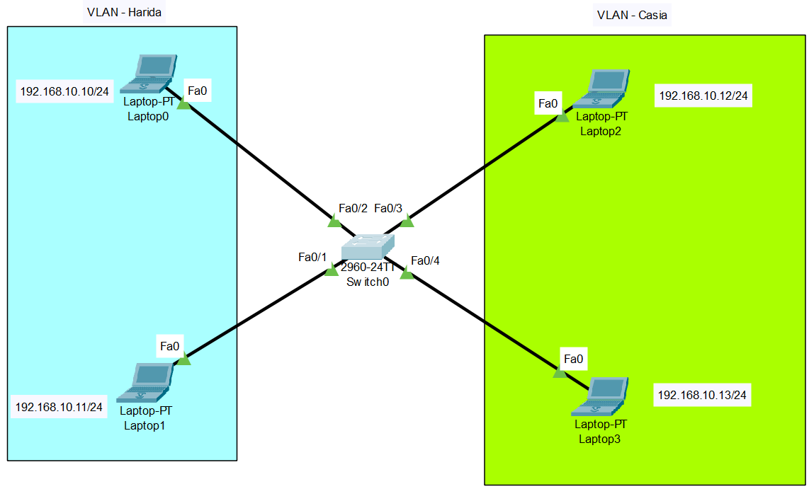

**Creating VLAN 10 – harida and VLAN 11 – Casia:**

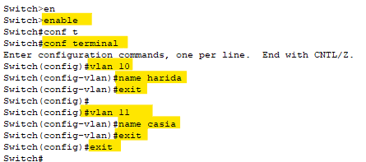

**Verify:**

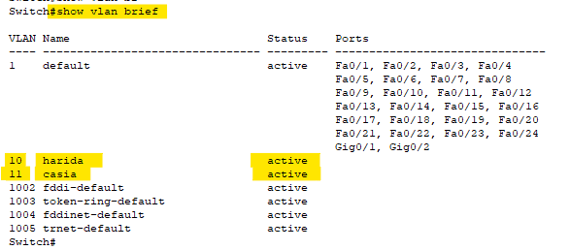

**Creating VLAN config for Harida**

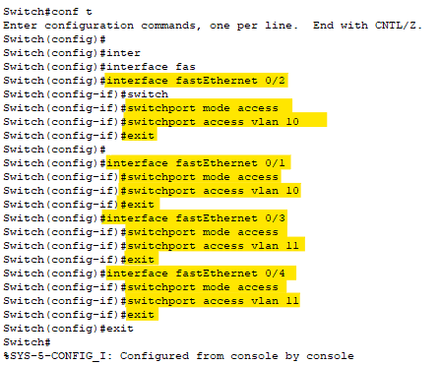

**Creating VLAN config for Casia**



**Verify:**

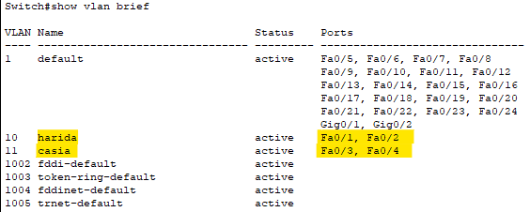

**After pinging system:**

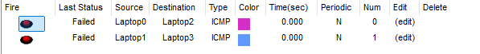

1. **Configure VTP using 3 switches:**

|  |
| --- |
| **Before configuring:**    **Enabling trunk mode on Switch 1:**      **Verifying VLAN mode on interface FA0/1 Switch 2:**    **Checking VLAN mode on interface FA0/2 – before changing:**    **Changing mode on interface FA0/2:**    **Verify on S2 after changes:**    **Verifying switch port on switch 3:**    **Checking trunk mode on all 3 switches:**  **S1: # show interfaces trunk**    **S2: # show interfaces trunk**    **S3: # show interfaces trunk**    **Switching to switch 1 and configuring VTP on it:**    **Changing VTP domain on Switch S1:**    **Checking VTP domain status on switch s2:**    **Checking VTP domain status on switch s3:**    **Creating VLAN on Switch S1:**    **Listing VLANs on S1:**    **Listing VLANs on S2:**    **Listing VLANs on Switch S2:** |

1. **Backing up switch to TFTP server.**

|  |
| --- |
| **Setting IP address for VLAN on switch:**    **Viewing current config:**    **Backing up TFTP server:**    **Verifying TFTP service on TFTP server:**    **After backup, make some changes on the switch (say changing the IP address on VLAN 1)**    **Verifying the IP address:** |

1. **Recovering switch data from the TFTP server.**

|  |
| --- |
| **Run below command on switch:**    **Verifying the configuration:** |
|  |